# **Product description for ITALKS MCS 1600 FULL LoRa modem**

The ITALKS MCS 1600 FULL Lora Modem is developed as a general purpose module that is able to integrate functionality for various applications and communicate with the widely available Low Power Wide Area Networks (LPWAN) LoRa.

Time to market is very important at this moment in the LPWAN market segment. The ITALKS MCS 1600 FULL module is developed to enable customers to be on the market in a matter of weeks. On request we can also supply a “Basic” version is the most used configuration for tracking purposes. It has GPS, LPWAN radio and an accelerometer, but all other sensors and circuits are not mounted.

This reduces the unit price.

For rapid prototyping and proof of concept use the ITALKS MCS 1600 FULL will be kept on stock as a “Full” version. For roll-out and larger volumes we can produce “off the shelf” any combination in between.

This works as follows:

Since the PCB size is dictated by the antennas and batteries, there is a lot of space available for other sensors. To decrease the time to market and avoid the risks associated with the development of new hardware and firmware the ITALKS MCS 1600 FULL version is designed and tested with as many sensors and circuits as we could place on the PCB. Once an application is developed and tested on the ITALKS MCS 1600 FULL version the ITALKS MCS 1600 FULL can be equipped with only the necessary circuits and sensors without the need to develop new hardware, firmware and application software or get new certifications.

If volumes of 500 or more are required we can produce the units with an application specific set of sensors and circuits to optimize unit prices. Please contact us on verkoop@mcs-nl.com for pricing of volumes of more than 500 pieces.

# **Product feature overview**

The full version has these on-board sensors and interfaces:

* One 2.4 GHz Bluetooth Low Energy (BT4.0), master and slave, short range radio for local wireless sensor networks and active RFID,
* One 2.4GHz mesh capable radio for inter-device communication,
* One 868/915 MHz radio for short range wireless sensor networks,
* One 868/915 MHz LoRa and Sigfox enabled LPWAN radio (bidirectional)
* One GPS/Glonass receiver, simultaneously tracking GPS and Glonass at -166 dBm.
* Supply voltage can be anywhere between 2.5 Volt and 5.0 Volt (3.6V nominal) which allows to fully use the capacity a Li-SOCl2 battery, but also allows for a 5V power source.
* One switchable 5V power output (200mA max) for external sensors and servos, even on a 2.0V power supply,
* One universal 2 channel bidirectional digital 5V sensor/actuator interface or COM port, IIC, etc.
* two combined analog inputs, range 0..5V, with 5mV resolution and/or open collector digital outputs (5V/1A)
* two LED’s for diagnose/feedback
* a 3D magnetometer
* a 3D accelerometer
* a high accuracy temperature/RHD sensor,
* a barometer (resolution 30cm air pressure)
* a 64 Kbyte nonvolatile memory for data logging or OTA firmware updates.
* A 10 pin expansion connector for external sensors and actuators or wired communication.

All 3 radio antennas are on the PCBA.

* A 868/915 MHz metal strip antenna for LPWAN and 868 radio.  
  Optionally this antenna can be replaced by a SMA connector to allow for an external antenna.
* A GPS/Glonass 25x25 patch antenna for geolocation reception.
* A 2.4GHz PCB antenna for Bluetooth and mesh networks.

# **Product feature details**

The universal 5V power supply and the 5V sensor interface is a way to support as many external sensors as possible with one simple circuit. When enabled it can source a 5V external device with a maximum of 100mA, and supports 2 bidirectional 5V I/O lines.

These lines can be used as a TTL-UART (serial), IIC interface, or simple digital I/O, to control for example a mechanical servo drive, LED’s, iButton and many more devices that use 5V DC power to operate. Of course there are only 2 pins, so if an interface type needs 2 pins you cannot use another interface in parallel.

It is however possible to have one pin as serial TX and the other as servo control or generic I/O.

The analog inputs are combined with open drain digital outputs. The default input sensitivity is 5V full scale, when used as outputs they can sink up to 1A to ground.

The inputs and outputs can be combined, reading analog voltage when the output is in the “Off” state. This enables for “load connected” detection.

Impedance for analog input is 338 KOhm.

The magnetometer is also called compass, but without calibration it cannot really be used as a compass. It can be used however to detect changes in earth magnetic field lines or to detect magnetic fields from permanent magnets or AC power lines.

Depending on the type and interval of measurements the power consumption can be as low as 10uA so it is possible to keep it “Always On” on a battery.

The accelerometer can be used to detect vibration, motion and to see the orientation in the earth’s gravitation field. Depending on the type and interval of measurements the power consumption can be as low as 10uA so it is possible to keep it “Always On” on a battery.

The temperature/humidity is a high precision sensor that can be used in applications like weather stations or HACCP related applications.

The temperature sensor has a resolution of 0.04 degrees Celsius and a accuracy of ± 0.3 degrees Celsius. The humidity sensor has a resolution of 0.04 %RH and a tolerance of 2.0 %RH. This sensor is on the PCB itself, so it cannot be used when the PCB is in a waterproof enclosure. Because the PCB uses very little power self heating is not a problem, but response time can be quicker when an external sensor is used.

The barometer is also a high precision sensor, it has a resolution of 30 cm air pressure.

Range is 50 to 110kPa, absolute accuracy ±0.4kPa, resolution ±0.05kPa.

Please consider that pressures changes as a result of wind and movement can be much larger than the static pressure as a result of height. Changes in atmospheric pressure are also much larger than pressure changes as a result of height.

The optional GPS/Glonass receiver including patch antenna is a very sensitive receiver that combines GPS as well as Glonass satellites to get an optimal position fix.

Both systems are used simultaneously which results in a very secure and accurate position. This receiver can be a serious power consumer if constantly enabled at full speed. It has however a lot of power saving modes, which will be optimized for a specific application.

The non-volatile memory is for data logging or can be used to store new firmware images that can be downloaded either over the air or by the 5V serial interface. When not used for firmware images the memory is available for storing application data.

The power regulator system is designed to make all required voltages from one power source as efficient as possible. The power supply can be anywhere between 2.0 V and 5.0 V, even when the radio or digital I/O needs 3.3 V or 5 V. This allows the device to use the full capacity of a LiPo or Li-SOCl2 battery. The circuits are optimized for use of primary batteries, but most rechargeable batteries or a 5V power source like USB can be used as well.

About batteries, power use and autonomy:

There are many types of batteries available, but there are 2 main groups: Primary and Rechargeable.

The most important difference (apart from the ability to recharge of course) is the self discharge current. For primary batteries this can be as low as 1% per year.

For rechargeable batteries it is much higher. Lithium Polymer cells experience a self-discharge rate of approximately 5% per month, compared with over 30% per month and 20% per month in NiHM batteries and NiCd batteries respectively.

Depending on the (interval of) use of GPS the ITALKS MCS 1600 FULL consumes between 6.7 mWh/day (4 fixes + 4 transmissions a day) and 100 mWh (90 minutes active GPS+120 transmissions a day)

These numbers are theoretical, based on prototypes and optimal radio conditions.

For GPS it takes less time to get a first fix when conditions are good, and the LPWAN can switch to higher bitrates when it is closer to the network so it can reduce the power consuming radio-on time.

The standard battery capacity for a basic version is 10800 mAh at 3.6V (or 38880 mWh).

When 4 fixes + transmissions a day are sufficient a primary battery of 10800 mAh will last 5762 days or more than 15 years.

At 52 mWh (90 minutes active GPS+120 transmissions) per day the battery will last for a little more than 1 years.

That is why we advise to use primary batteries.

When using rechargeable batteries with a self discharge of 5% per month about 50% of the capacity will be lost after 1 year, when using rechargeable batteries with a self discharge of 20% a month there is only 6% capacity remaining after one year. This is even without any load…

We supply three types of Li-SOCl2 primary battery packs.

* 10.800mAh 52 x 61 x 15 mm
* 18.000mAh 52 x 52 x 26 mm
* 38.000 mAh 63 x 67 x 33 mm

At this moment two types of enclosure are available that were developed for container tracking use. They support a 10.800 mAh battery pack which supports GPS/Glonass use for many months depending on the active profile.

For applications without GPS a much smaller battery can be used, and as a result of that a much smaller enclosure.

On request we can customize and white label the enclosure. Please email to [verkoop@mcs-nl.com](mailto:info@1m2m.eu) for further information.

# **Expansion connector**

For connecting external sensors and circuits there is a 10 pin expansion connector available.

Depending on the enclosure and application one out of 3 possible types is mounted.

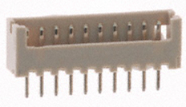

1. a straight angle connector type

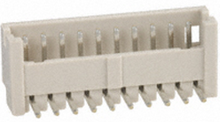

2. a right angle connector type

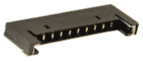

3. a very low profile right angle connector type

The first two connector types use this female connector

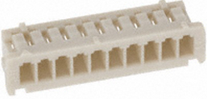

Manufacturer: Hirose Electric

Part number: DF13-10S-1.25C

Depending on the application 2 or more wires can be inserted on the locations that are used

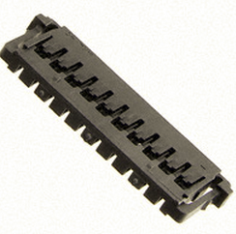

The low profile connector type uses this female connector:

Manufacturer: Molex

Part number: 5040511001

Depending on the application 2 or more wires can be inserted on the locations that are used.

|  |  |  |
| --- | --- | --- |
| Pin | Function | Explanation |
| 1 | Ground | Reference for all inputs, outputs and power |
| 2 | VBattery | Battery voltage 2.5 to 5.0 Volt, directly connected to the internal battery (if present). If not present this pin can be used to power the module |
| 3 | VLogic | Internal power supply voltage output. Depending on the power mode it can be 2.0V, 2.2V or 3.3V**. It is not allowed to connect anything to this pin except for circuits approved by MCS.** |
| 4 | Ground | Reference for all inputs, outputs and power |
| 5 | I/O switched 5V | Power output for 5V sensors or interfaces It is switched off in low power modes and can source 100mA max. Also powers DIO1 and DIO2 level converters and external hardware |
| 6 | DIO1/Rx/SDA | Generic digital IO. Can be used as serial port, IIC port or digital input or output. |
| 7 | DIO2/Tx/SCL | Generic digital IO. Can be used as serial port, IIC port or digital input or output. |
| 8 | AnIn1/Out1 | Digital power output. When activated it can sink 1000 mA.  When not activated it is also an analog input. Range 0..5VDC. Impedance is 338 KOhm to ground in this mode.  Maximum voltage is -0.2 VDC to +5 VDC. |
| 9 | AnIn2/Out2 | Same as AnIn1/Out1 |
| 10 | Ground | Reference for all inputs, outputs and power |

**Before connecting any circuits to this connector it is strongly advised to get support and approval from MCS. Please email at** [support@mcs-nl.com](mailto:support@mcs-nl.com)

**Any damage caused by non approved circuits voids warranty !**

For advise or additional information please contact us on [support@mcs-nl.com](mailto:support@mcs-nl.com)

# **Status LED’s**

There are 2 LED’s on the PCB for status information.

Both LED’s can show a number of short flashes (80ms on, 120ms off) every 2 seconds when the device is not in deep power down to show status of GPS, radio and sensors.

This behavior can be changed in configuration.

Default behavior red LED:

|  |  |
| --- | --- |
| On | LPWAN radio transmitting |
| 1 flash | LPWAN waiting for response |
| 2 flashes | LPWAN messages acknowledged |
| 3 flashes | LPWAN error |
| more | Future use or depending on configuration |

Default behavior green LED:

|  |  |
| --- | --- |
| Off | Device is asleep |
| 1 flash | Device is awake with activated sensors but has not activated GPS |
| 2 flashes | Device is awake and looking for a valid GPS fix |
| 3 flashes | Device is awake and has found a valid GPS fix |
| more | Future use or depending on configuration |

# **The tracker module enclosures with 10.800 mAh battery pack:**

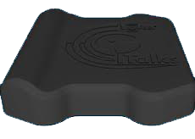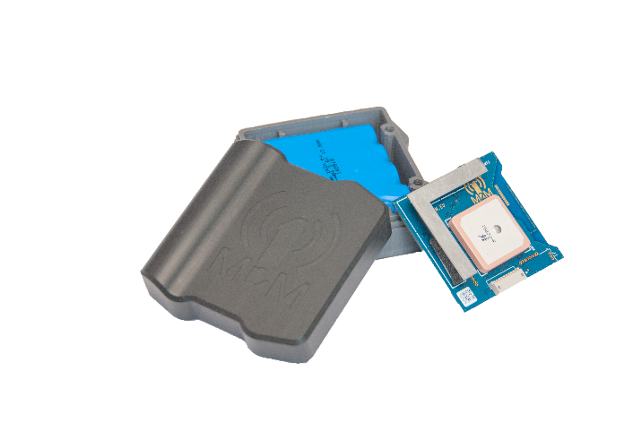

Size: 31/35 by 81/70 by 74mm

# **The tracker module enclosures with 2.7 mAh battery pack:**

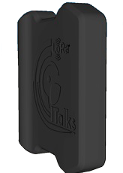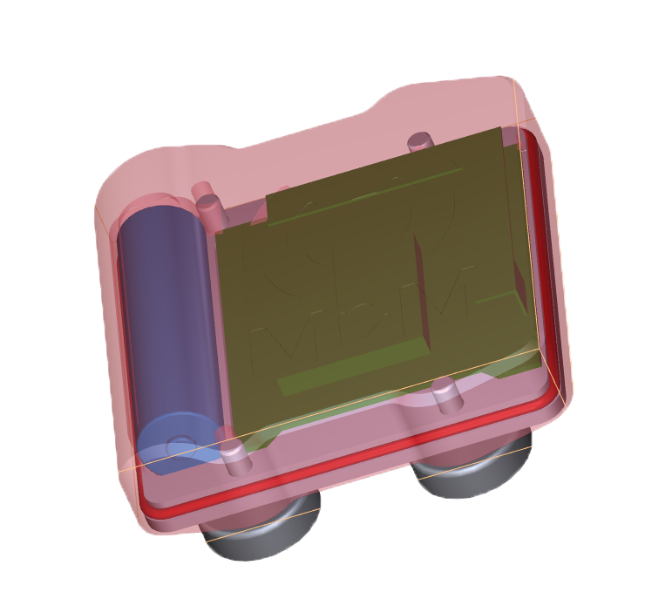

Size: 16/20 by 81/70 by 74mm (excl magnets)

# **Device Options**

|  |  |
| --- | --- |
| Option | Full |
| Semtech LoRa radio | X |
| Sigfox radio | X |
| 2.4GHz radio | X |
| Bluetooth 4.0 (BLE) | X |
| GPS/Glonass receiver | X |
| 3D Accelerometer | X |
| 3D Magnetometer | X |
| High resolution Barometer | X |
| Temperature sensor | X |
| Battery sensor | X |
| Relative humidity sensor | X |
| Extra NVM | X |
| 5V generator | X |
| 2 channel 5V IO-expander | X |
| 2 digital outputs/analog inputs | X |
| 2 diagnostic LED's | X |
| 4*2700mAh primary battery | X |

For quotes or advise on different sets of options or external sensors or circuitry please contact [verkoop@mcs-nl.com](mailto:info@1m2m.eu)

When the unit is idle battery consumption is approximately 30uA

When moving with GPS On battery consumption is on average 30mA

Battery life heavily depends on the amount of time the unit is moving